**PHP SORU – 6 : Dizi haline getir**

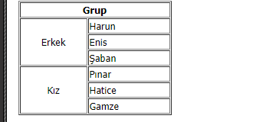

<!DOCTYPE html> <html lang="en"> <head> <meta charset="UTF-8"> <title>Soru - 6</title> </head>

<body> <?php

$grup = array( "GRUP" => [

"Kadın" => ["Pınar","Hatice","Gamze"],

"Erkek" => ["Harun","Enis","Şaban"] ]);

echo "<pre>";

print_r ($grup["GRUP"]);

print_r (count($grup["GRUP"]));

?>

</body>

</html>